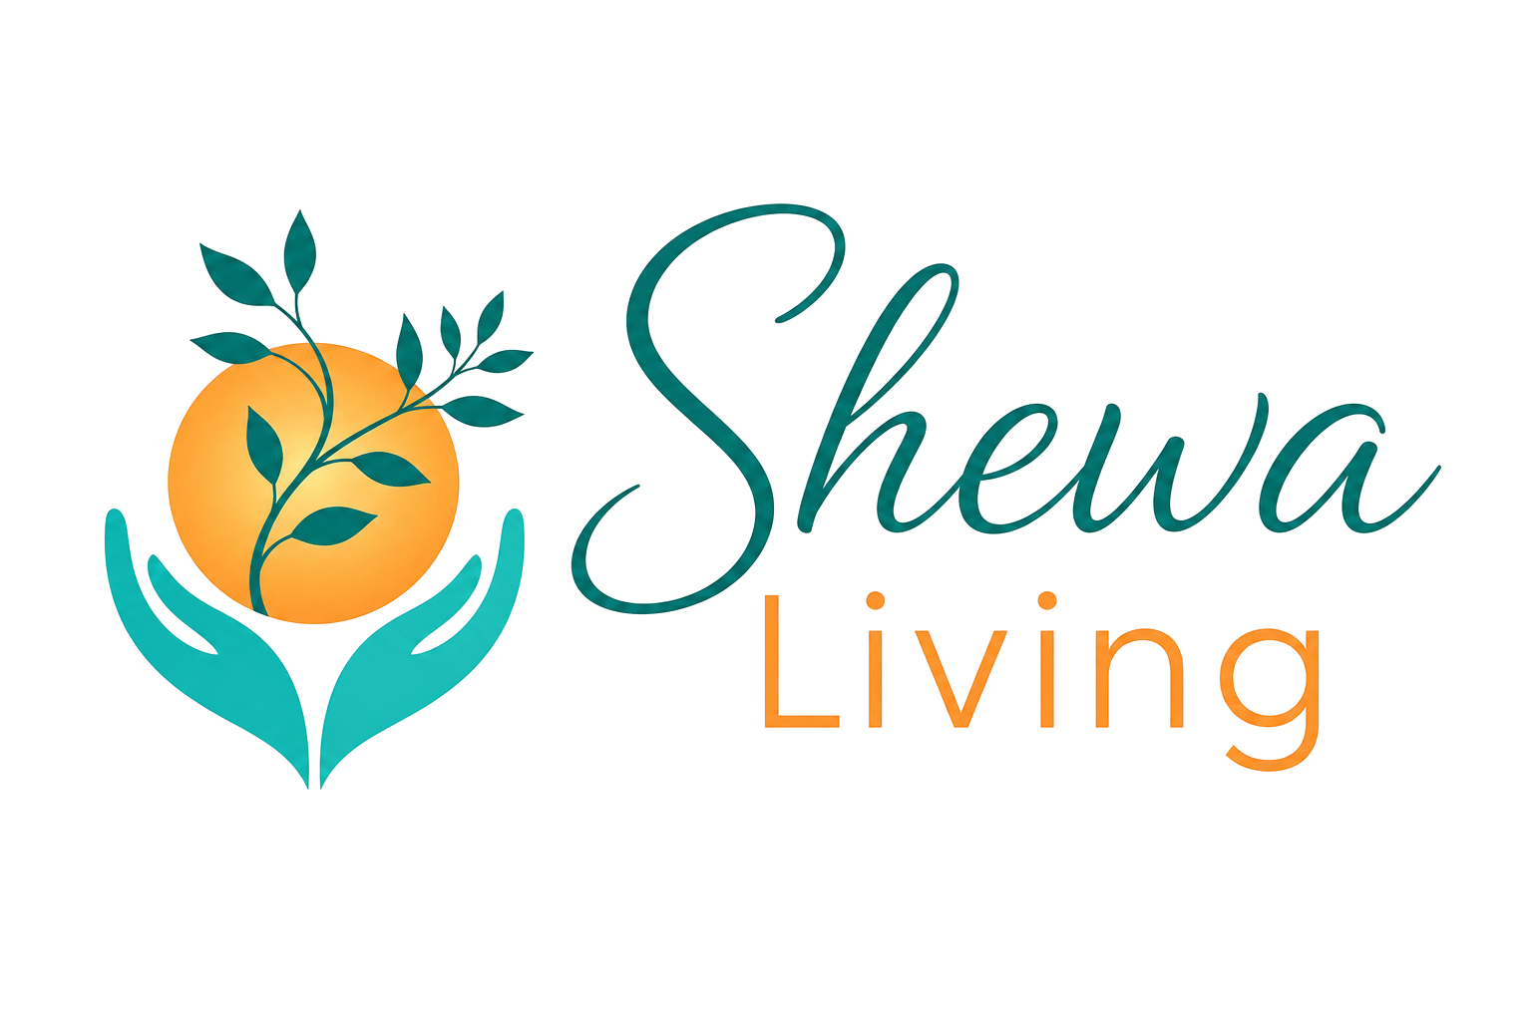 | Safeguarding Policy  Private Therapy & Work in Schools  Claire Donaldson | Holistic Therapist  www.shewaliving.co.uk | claire@shewaliving.co.uk | 07411 400 141

Policy owner | Claire Donaldson / Shewa Living
Applies to | Private therapy clients, children and young people, vulnerable adults, and work carried out in schools
Review | At least annually, and sooner if law, guidance, local procedures or working arrangements change
Version | September 2026

1. Our commitment
Safeguarding is everyone’s responsibility. As an independent therapist working with children, young people and adults, I take safeguarding seriously and aim to create a safe, respectful and supportive environment in every setting in which I work.
This policy explains what I will do if I am worried about someone’s safety or wellbeing, if a child or adult tells me something that concerns me, or if I become aware of information that may indicate abuse, neglect, exploitation or another safeguarding risk. I will listen, take concerns seriously, keep appropriate records and share information when this is necessary to protect someone from harm.

2. What safeguarding means
Safeguarding includes preventing harm and responding when there are concerns about abuse, neglect, exploitation or other risks to welfare. This can include physical, emotional or sexual abuse, neglect, domestic abuse, coercive or controlling behaviour, exploitation, online harm, bullying, radicalisation, self-harm or other forms of harm.
A concern does not need to be proved before it is acted upon. I will remain alert to changes in behaviour, presentation, communication, attendance, relationships or circumstances that may indicate a person needs help or protection.

3. The settings in which I work

Private therapy
When I am working privately, I am responsible for following this policy, relevant safeguarding law and guidance, and the safeguarding procedures of the relevant local authority or safeguarding partnership.
If I believe a child may be at risk of harm, I will contact the appropriate Children’s Social Care / safeguarding service or the police where appropriate. For an adult at risk, I will use the relevant adult safeguarding pathway. If there is immediate danger, emergency services will be contacted.

Work in schools
When I am working in a school, I will defer to the school’s safeguarding policy and procedures. I will follow the school’s child protection policy, reporting routes and safeguarding expectations and work with the school’s Designated Safeguarding Lead (DSL) or deputy DSL.
Where a safeguarding concern arises while I am working in school, I will report it without delay through the school’s agreed route, normally to the DSL. I will not investigate the concern myself or make decisions that properly belong to the school or statutory safeguarding agencies.
I will cooperate with the school and provide relevant information, observations or records when requested and when lawful and appropriate. I will follow the school’s arrangements for recording, information sharing, allegations about adults, low-level concerns, whistleblowing, emergency responses and referrals.
The school remains responsible for its own safeguarding systems and decisions. My responsibility is to recognise concerns, raise them promptly, follow the school’s process and support appropriate multi-agency working.

4. Current safeguarding framework
This policy sits alongside local safeguarding procedures and the policies of schools where I work. In England, the key framework includes:
- Working Together to Safeguard Children 2026.
- Keeping Children Safe in Education 2026, which applies to schools and colleges from 1 September 2026.
- The Children Act 1989 and Children Act 2004.
- Relevant safeguarding arrangements and guidance for adults at risk.
- Local safeguarding partnership procedures and threshold guidance.
- Current information-sharing and data-protection requirements.
I will keep this policy under review as safeguarding guidance, legislation and local procedures develop.

5. Key changes from September 2026
Working Together to Safeguard Children 2026 reinforces safeguarding as a shared responsibility and strengthens expectations around multi-agency working, inclusive and anti-discriminatory practice, hidden harms and effective information sharing.
Keeping Children Safe in Education 2026 comes into force on 1 September 2026. For people working with schools, it reinforces the need to act promptly on concerns, follow the school’s child protection policy, share information when necessary to protect a child, keep clear records and use the school’s procedures for concerns or allegations about adults, including contractors and other people working with pupils.
A new statutory information-sharing duty introduced by the Children’s Wellbeing and Schools Act 2026 also applies from September 2026. It reinforces that relevant information may need to be shared to help safeguard and promote a child’s welfare. It does not replace existing safeguarding procedures.

6. Recognising concerns
I will be alert to concerns including, but not limited to:
- Physical, emotional or sexual abuse.
- Neglect or unmet basic needs.
- Domestic abuse, including its impact on children.
- Coercive or controlling behaviour and abusive behaviour in relationships.
- Child sexual exploitation, criminal exploitation or other exploitation.
- Bullying, harassment or discriminatory abuse.
- Online abuse, grooming, exploitation or other online harms.
- Radicalisation or concerns relating to extremism.
- Self-harm, suicidal thoughts or other immediate risks to safety.
- Abuse or neglect of an adult at risk, including financial or psychological abuse.
- Concerns about another adult working with or around children or vulnerable adults.
- Any other situation where someone appears to be at risk of significant harm or where early help may be needed.

7. If someone tells me something
If a child, young person or adult makes a disclosure or tells me something that causes concern, I will:
- Stay calm, listen carefully and allow them to speak in their own words.
- Take what they say seriously and avoid promising to keep it secret.
- Avoid leading questions or trying to investigate what has happened.
- Explain, calmly and appropriately, that I may need to share information to help keep them or someone else safe.
- Make a factual record as soon as possible, using the person’s own words where practical.
- Report or refer the concern through the correct safeguarding route without unnecessary delay.

8. Confidentiality and information sharing
Confidentiality is an important part of therapy, but it is not absolute. Safeguarding concerns take priority over confidentiality where information needs to be shared to protect a child or adult from harm.
I will share information carefully, proportionately and through appropriate channels. I will not delay a necessary safeguarding referral because consent has not been given where there is a lawful safeguarding basis for sharing. I will record what was shared, with whom, why it was shared and relevant decisions.
When working in a school, I will follow the school’s information-sharing and recording procedures and provide relevant information to the DSL or other appropriate person.

9. Recording and record keeping
Safeguarding records will be factual, clear, dated and kept securely. I will distinguish between what I have seen or heard, what has been reported to me and any professional judgement or action taken.
- Record concerns as soon as reasonably possible.
- Use the person’s own words where relevant and avoid unnecessary assumptions.
- Record actions taken, decisions made, the reason for decisions and any known outcome.
- Keep safeguarding information appropriately protected within client records.
- Share records when required by safeguarding procedures or lawful requests.
- Follow the school’s recording system and requirements when working in school.

10. Concerns or allegations about me
If a concern or allegation is made about me, I will not investigate it myself. I will cooperate with the appropriate safeguarding process and any relevant school, local authority, police or other statutory agency.
When working in a school, any concern or allegation about my conduct in relation to a pupil will be handled through the school’s safeguarding and allegations procedures, including local authority arrangements where required. I will follow the direction of the school and relevant safeguarding agencies.

11. Safer working practice
- Maintain clear professional boundaries and avoid conflicts of interest.
- Use age-appropriate communication and professional language.
- Avoid unnecessary physical contact and ensure therapeutic activities are appropriate and explained.
- Use appropriate communication methods and maintain professional records.
- Take reasonable steps to protect privacy and safety during sessions.
- Follow school rules and supervision arrangements when working on school premises.
- Keep safeguarding knowledge and training up to date.

12. Safer recruitment and DBS
Shewa Living is currently operated by Claire Donaldson as a sole practitioner. If another person is engaged to work with children or vulnerable adults on behalf of Shewa Living, appropriate safer recruitment, references, identity checks, DBS checks and suitability checks will be considered and completed as required for the role.
When working in schools, I will comply with the school’s requirements for external practitioners and contractors, including any DBS, induction, safeguarding training, identification, supervision or documentation requirements.

13. Risk assessment and safe environments
I will consider safeguarding risks in the places and circumstances in which I work, including the physical environment, privacy, access, lone working, communication, online contact and individual vulnerabilities.
Where I work in a school, the school’s own risk assessments, site procedures and safeguarding arrangements will apply.

14. Early help and working with families
Safeguarding is not only about responding to serious harm. Where appropriate, I will recognise when a child, young person or family may benefit from additional support and will signpost or refer through the appropriate early-help or local service pathway, in line with local procedures.
I will aim to work respectfully with children, young people, parents and carers, while recognising that information may need to be shared without consent when safeguarding requires it.

15. Equality, inclusion and respectful practice
I will aim to provide an inclusive, non-discriminatory service and will take concerns about racism, discrimination, bullying or other harmful behaviour seriously. I will consider how identity, communication needs, disability, family circumstances or other vulnerabilities may affect a person’s experience and access to support.

16. Emergencies
If someone is in immediate danger or there is an immediate risk of serious harm, emergency services should be contacted; in England this will normally be 999. I will then follow the relevant safeguarding procedure and notify the appropriate school or safeguarding professional where applicable.

17. Contacts and local procedures
Local safeguarding arrangements and referral routes vary. I will use the current procedures for the local authority or safeguarding partnership in the area where the concern arises.
For school work, the first safeguarding contact will normally be the school’s DSL or deputy DSL, using the school’s agreed reporting route.
For private work, I will use the relevant local authority children’s safeguarding / adult safeguarding service or the police, as appropriate. Emergency concerns should be directed to 999.

18. Training, supervision and professional development
I have completed safeguarding training in September 2026 as in-house training at St Anne’s Primary School, Sale.
I will maintain appropriate safeguarding training and update my knowledge regularly. Safeguarding training and knowledge will be reviewed at least annually and sooner where guidance or my work changes.
Where appropriate, I will seek professional supervision or advice when managing safeguarding concerns, while ensuring that advice-seeking does not cause an unsafe delay in reporting a concern.

19. Review of this policy
This policy will be reviewed at least annually and whenever there is a significant change in safeguarding law, statutory guidance, local safeguarding procedures, school requirements or the way Shewa Living works.
This policy is intended to be practical and easy to follow. It does not replace a school’s safeguarding policy or the procedures of a local safeguarding partnership or statutory agency.

20. Key guidance used
Updated with reference to current England safeguarding guidance available in September 2026, including Working Together to Safeguard Children 2026, Keeping Children Safe in Education 2026 and the new statutory information-sharing duty commencing in September 2026.

